Ex.no:6b | DATA VISUALIZATION USING POWER BI

AIM

To visualize and analyze the Food Waste Prediction Dataset using Line Chart, Bar Chart, Pie Chart, Histogram, Scatter Plot, and Box Plot with Matplotlib to understand food waste trends, city-wise and restaurant-wise comparisons, food item distribution, waste patterns, and relationships between food waste-related attributes.

ALGORITHM

Step 1: Import Pandas and Matplotlib libraries.

Step 2: Load the Google Play Store dataset into a DataFrame.

Step 3: Reconstruct the application Category from the encoded category attributes and calculate the average rating for each category.

Step 4: Plot the category-wise average rating using a Line Chart to observe variations in application ratings across different categories.

Step 5: Group the dataset according to Category and calculate the total number of Reviews for each category.

Step 6: Plot the category-wise reviews using a Bar Chart to compare application popularity across different categories.

Step 7: Group the dataset according to Type and calculate the number of Free and Paid applications.

Step 8: Plot the Free and Paid application distribution using a Pie Chart.

Step 9: Select the Rating attribute and plot a Histogram to understand the distribution of application ratings.

Step 10: Select Reviews and Installs attributes and plot a Scatter Plot to analyze the relationship between application reviews and installations.

Step 11: Select the Rating attribute and plot a Box Plot to identify the distribution, spread, and possible outliers in application ratings.

Step 12: Add suitable titles, axis labels, legends, and display all the visualizations.

CODE
import pandas as pd
import matplotlib.pyplot as plt
from google.colab import files

uploaded = files.upload()

file_name = list(uploaded.keys())[0]

df = pd.read_csv(
file_name,
encoding="latin1",
low_memory=False
)

category_columns = [col for col in df.columns if col.startswith("Category_")]

if category_columns:
df["Category"] = (
df[category_columns]
.idxmax(axis=1)
.str.replace("Category_", "", regex=False)
)

for column in ["Rating", "Reviews", "Installs", "Price"]:
if column in df.columns:
df[column] = pd.to_numeric(
df[column].astype(str)
.str.replace("$", "", regex=False)
.str.replace(",", "", regex=False),
errors="coerce"
)

category_rating = df.groupby("Category")["Rating"].mean()

plt.figure(figsize=(12, 5))
plt.plot(
category_rating.index,
category_rating.values,
marker="o"
)
plt.title("Average Rating by Category")
plt.xlabel("Category")
plt.ylabel("Average Rating")
plt.xticks(rotation=90)
plt.grid(True)
plt.tight_layout()
plt.show()

category_reviews = (
df.groupby("Category")["Reviews"]
.sum()
.sort_values(ascending=False)
.head(10)
)

plt.figure(figsize=(12, 6))
plt.bar(
category_reviews.index,
category_reviews.values
)
plt.title("Top 10 Categories by Total Reviews")
plt.xlabel("Category")
plt.ylabel("Total Reviews")
plt.xticks(rotation=45, ha="right")
plt.tight_layout()
plt.show()

type_distribution = df["Type"].value_counts()

plt.figure(figsize=(8, 8))
plt.pie(
type_distribution.values,
labels=type_distribution.index,
autopct="%1.1f%%"
)
plt.title("Free and Paid Application Distribution")
plt.show()

plt.figure(figsize=(8, 6))
plt.hist(
df["Rating"].dropna(),
bins=10
)
plt.title("Distribution of Application Ratings")
plt.xlabel("Rating")
plt.ylabel("Number of Applications")
plt.tight_layout()
plt.show()

scatter_df = df[["Reviews", "Installs"]].dropna()

plt.figure(figsize=(8, 6))
plt.scatter(
scatter_df["Reviews"],
scatter_df["Installs"],
alpha=0.5
)
plt.title("Reviews vs Installs")
plt.xlabel("Reviews")
plt.ylabel("Installs")
plt.tight_layout()
plt.show()

plt.figure(figsize=(8, 6))
plt.boxplot(
df["Rating"].dropna()
)
plt.title("Box Plot of Application Ratings")
plt.ylabel("Rating")
plt.tight_layout()
plt.show()
OUTPUT

LINE CHART
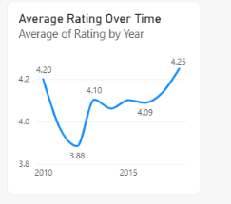

BAR CHART
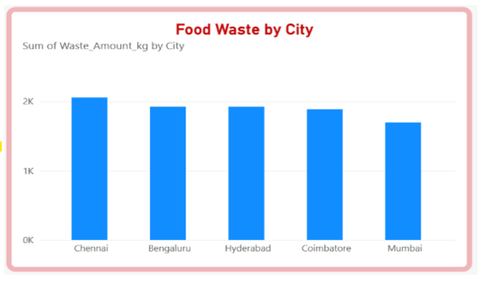

PIE CHART
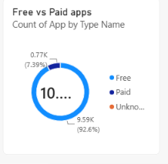

RESULT

